**Assignment 28.1**

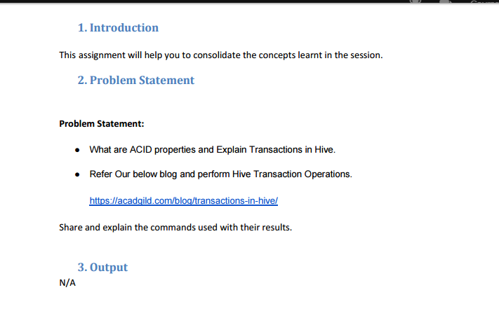

**Properties of ACID in Hive:**

ACID stands for:

* **A**tomicity
* **C**onsistency
* **I**solation and
* **D**urability

***Atomicity:***

* Atomicity - transaction which happened should be completed or should get failed instead.
* i.e. it should never be partially completed.

***Consistency:***

* Consistency will make sure whatever the transaction happens the database will be collected from one valid state to another state.

***Isolation:***

* Isolation – means all the transaction have been through should be independent of each other
* i.e. a transaction which was happening should not another transaction.

***Durability:***

* Durability – means once a transaction gets completed they should be stored it in the database.
* And it is compulsory even when the machine state gets lost or the system gets failed.
* ACID properties plays a important role while transaction.
* As well all the transaction should make sure that all properties are met.

**Hive Transactions:**

* Hive Transaction was first introduced as Hive 0.13 version.
* But all the ACID properties were only partially fulfilled like atomicity, consistency, durability, at the partition level.
* By tuning the locking mechanism Isolation can be turned on using zookeeper or in memory.
* Incase of Hive 0.14 version, new API’s were introduced to fulfill the ACID properties during transaction process.
* Transactions were done at row-level in Hive 0.14 version.
* There are different types of row-level transactions which was available in Hive 0.14and they are:

1. *Insert*
2. *Delete*
3. *Update*

* There are number of limitations for present transactions which is available in Hive 0.14 version.
* ORC is a file format which supports the Hive transaction.
* ORC file format have become essential for performing transactions in Hive.
* The table are needed in order to be bucketed to support the transactions.

**Transaction Operations in Hive:**

* Before Hive table is created they use to support transactions.
* But transaction features in Hive should be turned on.
* By default they will turned off.
* There are certain properties that need to be set in hive shell, in a order-wise manner in order to work transactions in Hive:
* If the properties are not properly set then ‘Insert’ operation will work.
* In parallel ‘Update’ and ‘Delete’ operation will not work
* And the following error will be shown on the screen:

|  |  |
| --- | --- |
| 1 | FAILED: SemanticException [Error 10294]: Attempt to do update or delete using transaction manage. |

**Creating a Table which Supports the Hive Transactions:**

* Create a table with name ‘emptxn’
* the columns should represent ‘id, name, salary,dept’.
* the table is bucketed by ‘dept’
* table format - ‘orc’.
* transactions is enabled in the table by using it inside the tableproperties as ‘transactional’=’true’.

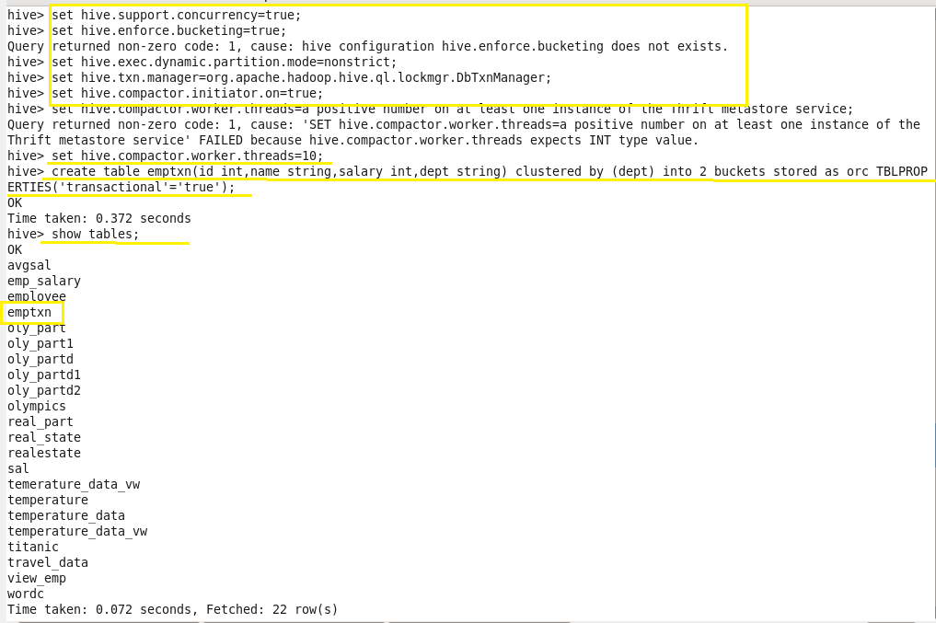

**Inserting values into table:**

* Here records were inserted into table row wise.
* Here, each row will be separated by ‘( )’ brackets.

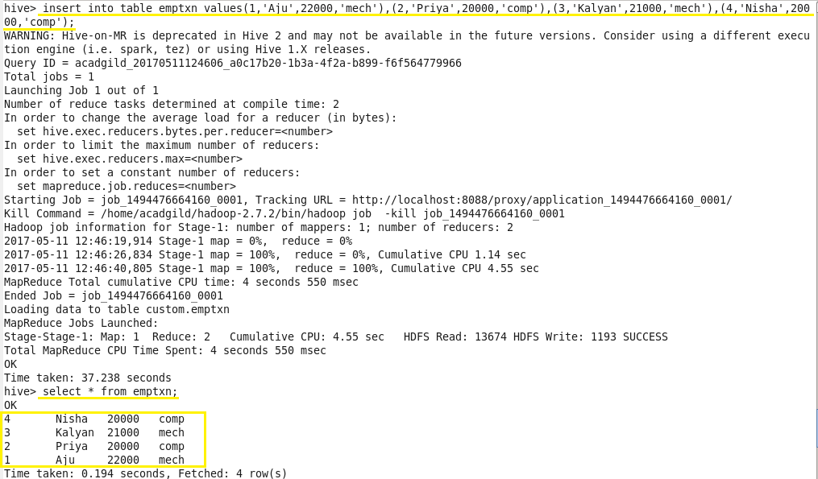

When a same value is inserted again then those will be appended to previous data as mentioned below:

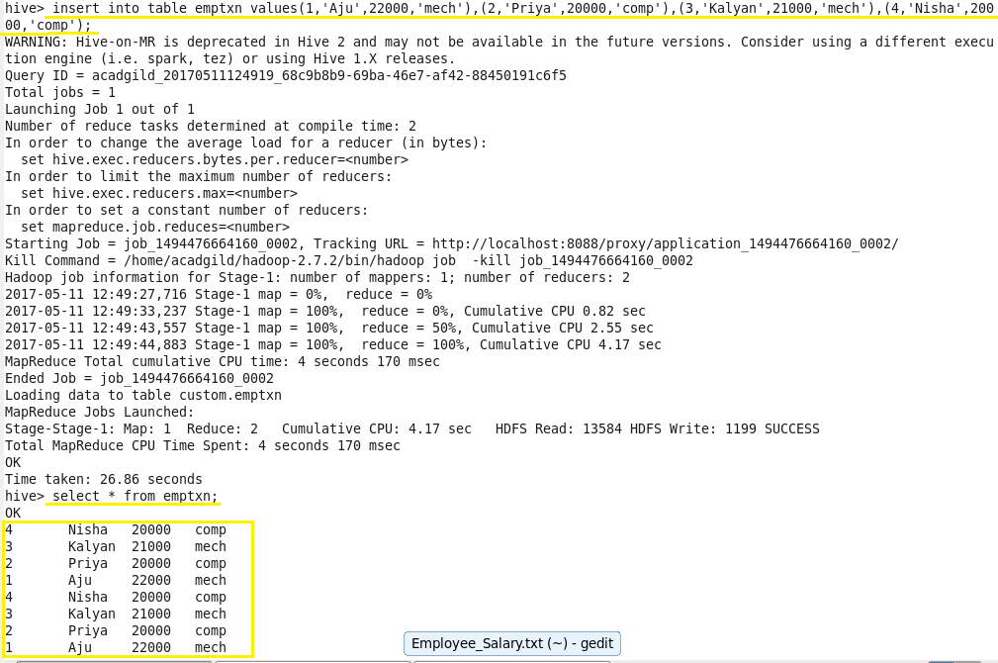

**Updating Data in Hive Table:**

**Bucketed columns:**

* The Update command will not be supported on the columns which were bucketed.
* Here we have bucketed **‘dept’** column
* And we perform Update operation on the same column
* And the error obtained was:

**FAILED: SemanticException[Error 10302]:**

**Updating values of bucketing columns is not supported. Column dept.**



**Non-bucketed columns:**

**When update operation is performed on** the **non-bucketed** **column then the data will be updated successfully.**

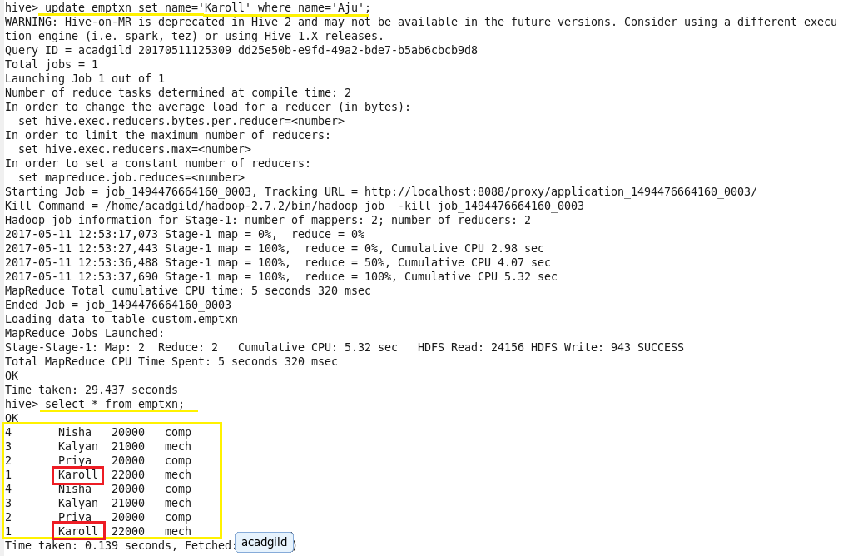

**Deleting a Row from Hive Table:**

* When one need to delete the records which contains the name Nisha.
* All the records for the name Nisha will get deleted once this code get executed.
* By using “select * from emptxn” we can check the program.

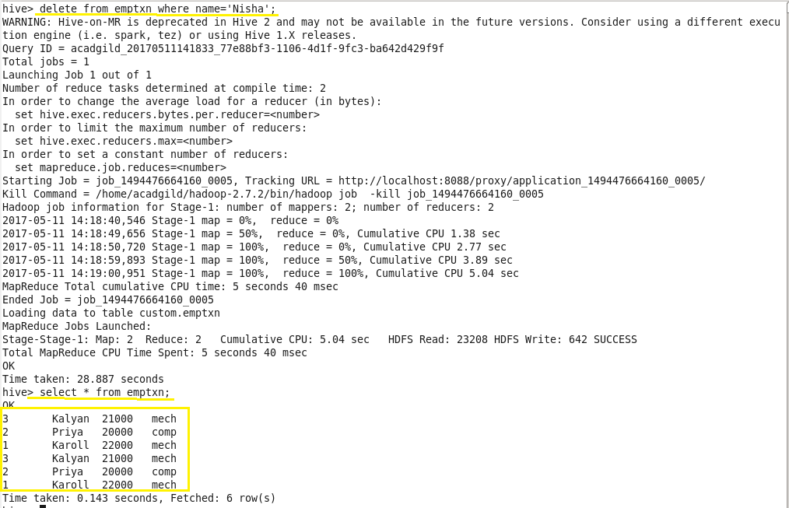

* In the output no row with **name =’Nisha’ will be found**.
* So that row is successfully deleted from the Hive table.
* Like this the transactions or row-wise operations in Hive is performed.